PVG’s College of Engineering & Technology & GKPIM, Pune
Department Of Electronics and Telecommunication
BE Project Academic Year 2023-2024
Synopsis

- Title of Project: A GEO-INTELLIGENT CROP ADVISOR AND MARKET PREDICTOR SYSTEM FOR FARMERS
- Abstract:
The work begins with a brief overview of types, design techniques, research challenges, and objectives discussed. The previous work done by researchers related to the crop prediction system using different Machine Learning approaches. It is a web-based application which is helpful for the farmers. Over the most recent couple of years analysts have been keen ashore planning and its arrangement for different reasons. The intention behind the expansion is that soil strength is fundamental, so growing interest in farmland and soil condition research is fundamental to solid yield generation. The image sequence is one of his methods of studying soil and land health. It’s an amazing way to take into account the influence of different components. This paper proposes the investigation of flow and explores the issues it tends to and its possibilities. The focus is on a logical analysis of numerous cutting-edge grouping systems and techniques. To improve the precision of these methodological characterization, an attempt was made to look at the factors that gave rise to them. A convolutional neural network algorithm is used to classify the soil images in 4 categories Red, Black, Alluvial, Clay. A random forest algorithm is used to suggest crops based on soils also, we are predicting the humidity, rainfall, and temperature. Using KNN we are recommending the shop to the user. In this project, we achieve 81.25% accuracy by using random forest and 99% by the known model.

- Objectives:
  - To detect the soil type using CNN.
  - To predict the crops using Random Forest.
  - To improve the performance of the model.
  - To predict shops using KNN.
  - To develop the most effective crop-predicting system using a machine learning algorithm.

- Outcomes:
  - To recommend the crops.
  - To recommend the Ph, rainfall, and Temperature.
  - To recommend the industry.

- Specifications of Project:
- Database

- Database - SQLite

- Software Specification

- Operating System:- Windows
- Front End - Python3x
- Database-SQLite3
- IDE - Py-Charm
- Framework - Django

- Hardware Specification

- Processor - I3
- Speed - 1.1 GHz
- RAM - 2 GB (min)
- Hard Disk - 20 GB

- System Block Diagram:
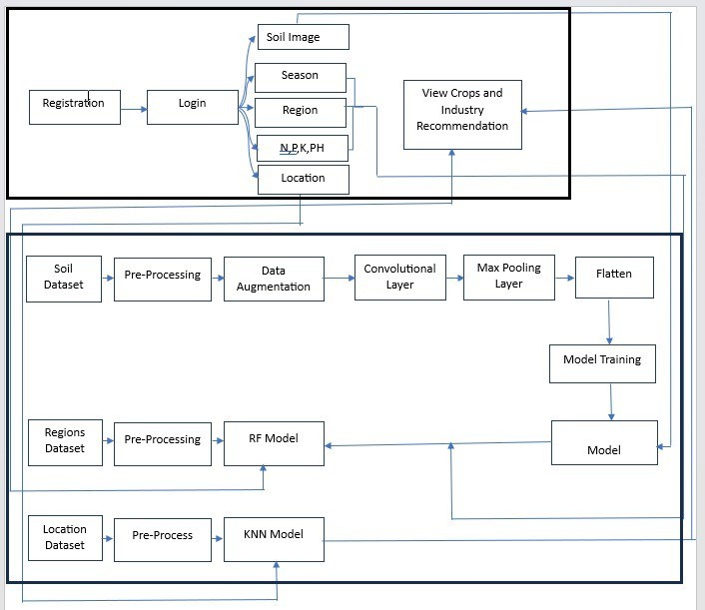

- Software Simulation Results:

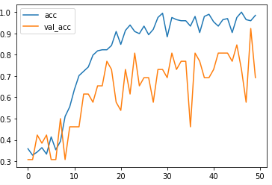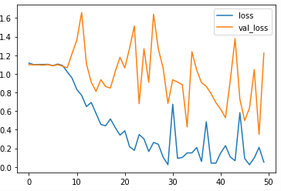
Figure: CNN Accuracy diagram: 50 Epochs Figure: CNN Loss diagram: 50 Epochs

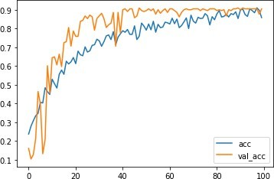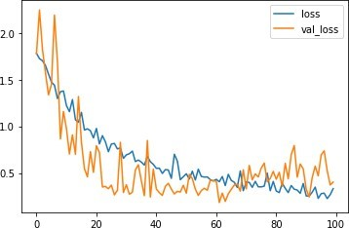
Figure: CNN Accuracy diagram: 100 Epochs Figure: CNN Loss diagram: 100 Epochs


Figure: Registration Form Figure: Login Form

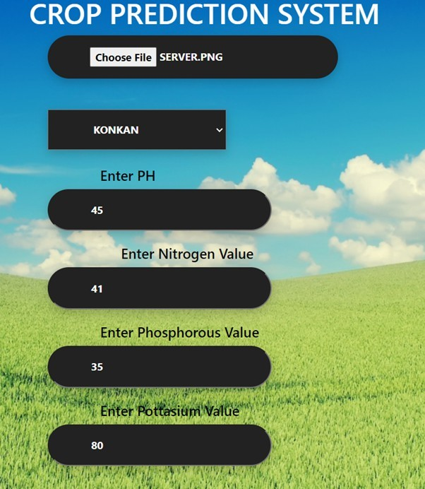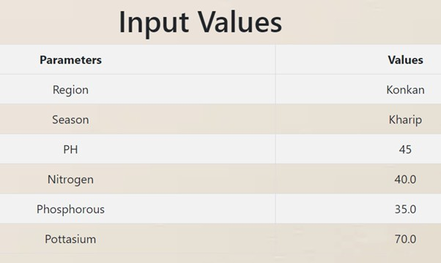
Figure: Home Page: Crop Prediction Figure: Result Page: Crops Predicted

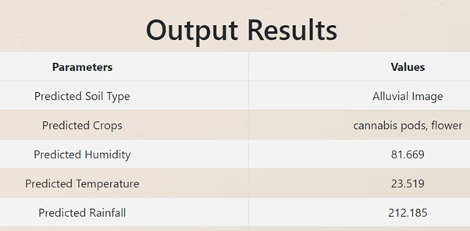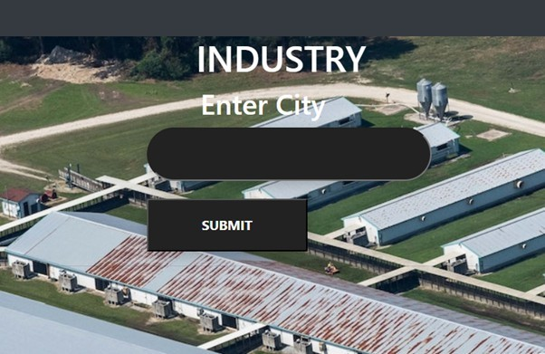
Figure: Result Page: Crops Predicted Figure: Home Page: Industry

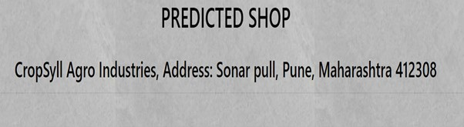
Figure: Result Page: Shop

- Project Type
Our project promotes sustainability by considering environmental conditions, community engagement, and green initiatives. By analyzing soil images, seasonal data, region specifics, and soil nutrients (N, P, K, pH), we recommend crops that are best suited to the local environment. This helps to maintain soil health, reduce the use of chemical fertilizers, and conserve water. Furthermore, by suggesting the nearest industries for crop processing, we support local businesses and reduce transportation emissions. This integration encourages community development and strengthens local economies. Overall, the project supports sustainable farming practices, fosters community involvement, and promotes environmentally friendly agriculture.
- Project Domain: AI, ML

- References
- Madhuri Shripathi Rao1, Arushi Singh1, N.V. Subba Reddy1 and Dinesh U Acharya “Crop prediction using machine learning” Journal of Physics: Conference Series AICE- CS 2021.

- Sonal Agarwal1 and Sandhya Tarar2 “A Hybrid Approach For Crop Yield Prediction Using Machine Learning And Deep Learning Algorithms” Journal of Physics: Conference Series CONSILIO 2020.

- Pavan Patil1, Virendra Panpatil2, Prof. Shrikant Kokate3 “Crop Prediction System using Machine Learning Algorithms”. International Research Journal of Engineering and Technology (IRJET) Volume: 07 Issue: 02 | Feb 2020.

- Surili Agarwal, Neha Bhangale, Kameya Dhanure, Shreeya Gavhane, V.A.Chakka- rwar, Dr. M.B.Nagori “Application of Colorimetry to determine Soil Fertility through Naive Bayes Classification Algorithm” 9th ICCCNT 2018 July 10-12, 2018, IISC, Bengaluru.

- Sk Al Zaminur Rahman, Kaushik Chandra Mitra, S.M. Mohidul Islam “Soil Classifi- cation using Machine Learning Methods and Crop Suggestion Based on Soil Series” 2018 21st International Conference of Computer and Information Technology (ICCIT), 21-23 December 2018.

- Dhanush Vishwakarma “Crop Prediction using Machine Learning Approaches” Intern- ational Journal of Engineering Research Technology (IJERT).

- Rageena P.M et al. “Agriculture Crop Prediction System Based on Meteorological Information” International Journal of Control Theory and Applications ISSN: 0974-5572.

- Prof. D.S. Zingade ,Omkar Buchade ,Nilesh Mehta ,Shubham Ghodekar ,Chandan Mehta “Crop Prediction System using Machine Learning”.

- Ashwani Kumar Kushwaha, Swetabhattachrya “crop yield prediction using the agro algorithm in Hadoop”.

- Girish L, Gangadhar S, Bharath T R, Balaji K S, Abhishek K T “Crop Yield and Rainfall Prediction in Tumakuru District using Machine Learning”.

Name of students:

ADITYA VILAS CHAVAN Exam No. B190073025

TEJAS GOPAL KULKARNI Exam No. B190073084

DARSHAN VIJAY PAKHALE Exam No. B190073108

ANUSHRAY NITIN PINGALE Exam No. B190073119

Prof. A. S. Najan

Name of Guide and Signature

